**AIM : TO FIND NEEDS FROM THE LIST BY USING LIKE AND BETWEEN COMMAND**

select * from student where name like "c%";

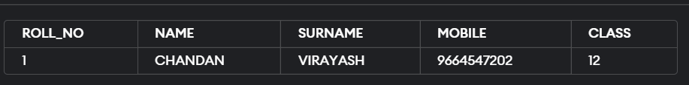

select * from student where name like "A%";

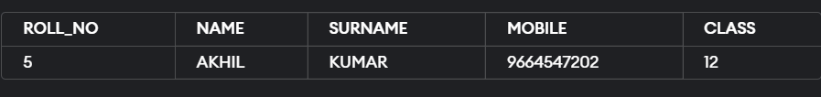

select * from student where ROLL_NO BETWEEN 1 AND 4;

